Year 10
OLNA class

Test 1.2

2018

Time


Name: ______________________ Class: ______ Time: 10 minutes (strict) Total Mark:____/8

Resources: No calculator allowed

Question 1 2 marks

Here is the calendar for August 1998.
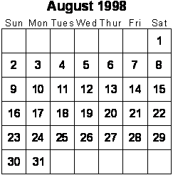
- Simon's birthday is on August 20th. In 1998 he had a party on the Sunday after his birthday. What was the date of his party?

- Tina's birthday is on September 9th. On what day of the week was her birthday in 1998?

Question 2 1 mark

These are the start and finish times on a video cassette recorder.
START 14:45
FINISH 17:25
For how long was the video recording?
hours minutes

Question 3 2 marks

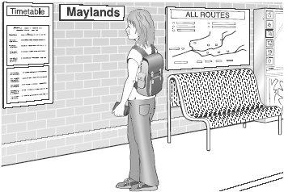
Here is part of the morning train timetable from Perth to Midland in Australia.

Perth | 07:11 | 07:20 | 07:27 | 07:35 | 07:43 | 07:55
Maylands | – | 07:28 | 07:33 | 07:43 | 07:49 | 08:03
Ashfield | – | – | 07:38 | – | 07:54 | –
Success Hill | 07:25 | – | 07:41 | – | 07:57 | –
Midland | 07:32 | 07:41 | 07:48 | 07:56 | 08:05 | 08:16

- What time is the first train from Maylands that stops at Success Hill?

- Mr Evans is in Perth and wants to be in Midland by 08:00. What is the time of the latest train he can take from Perth?

Question 4 1 mark

A film starts at 6:45pm. It lasts 155 minutes. What time will the film finish?

A 2120 B 2110 C 2100 D 2130

Question 5 1 mark

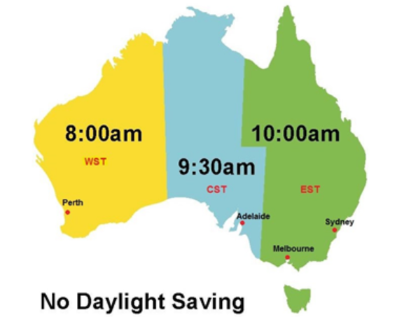
Use this knowledge of Australian time zones during non-daylight saving periods to state the time in Adelaide if it is 20 minutes to 9 on Thursday night in Melbourne.
A 10 minutes before 9 on Thursday night | B 10 minutes pass 9 on Thursday night | C 10 minutes pass 8 on Thursday night | C 10 minutes to 8 on Thursday night

Question 6 1 mark

The clock shows the same time as one of the watches. Draw a line to match the clock to a watch.
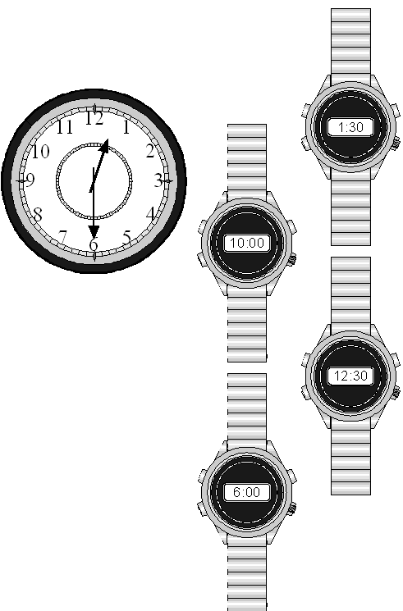

END OF TEST

ANSWERS
Year 10
OLNA class

Test 1.2

2018

Time


Name: ______________________ Class: ______ Time: 15 minutes (strict) Total Mark:____/11

Resources: No calculator allowed

Question 1 2 marks

Here is the calendar for August 1998.

- Simon's birthday is on August 20th. In 1998 he had a party on the Sunday after his birthday. What was the date of his party?

23rd of August OR 23.8.98

- Tina's birthday is on September 9th. On what day of the week was her birthday in 1998?

Wednesday

Question 2 1 mark

These are the start and finish times on a video cassette recorder.
START 14:45
FINISH 17:25
For how long was the video recording?
hours minutes
2 (hours) 40 (minutes)
Question 3 2 marks


Here is part of the morning train timetable from Perth to Midland in Australia.

Perth | 07:11 | 07:20 | 07:27 | 07:35 | 07:43 | 07:55
Maylands | – | 07:28 | 07:33 | 07:43 | 07:49 | 08:03
Ashfield | – | – | 07:38 | – | 07:54 | –
Success Hill | 07:25 | – | 07:41 | – | 07:57 | –
Midland | 07:32 | 07:41 | 07:48 | 07:56 | 08:05 | 08:16

- What time is the first train from Maylands that stops at Success Hill?

07:33

- Mr Evans is in Perth and wants to be in Midland by 08:00. What is the time of the latest train he can take from Perth?

07:35

Question 4 1 mark

A film starts at 6:45pm. It lasts 155 minutes. What time will the film finish?

A 2120 B 2110 C 2100 D 2130
2120
Question 5 1 mark


Use this knowledge of Australian time zones during non-daylight saving periods to state the time in Adelaide if it is 20 minutes to 9 on Thursday night in Melbourne.
A 10 minutes before 9 on Thursday night  B | B 10 minutes pass 9 on Thursday night | C 10 minutes pass 8 on Thursday night | C 10 minutes to 8 on Thursday night

Question 6 1 mark

The clock shows the same time as one of the watches. Draw a line to match the clock to a watch.


12.30.

END OF TEST

